Workflow Functional Document

Application: | NGERP-CENTRA
WorkFlow: | Quote To Cash
WorkFlow Item Name: | Import Promotion Order

Description:
This function is used to import the Promotion Order details into the NGERP system if the file name starts-with SYN_SALE_ORDER.

Work Flow Process:

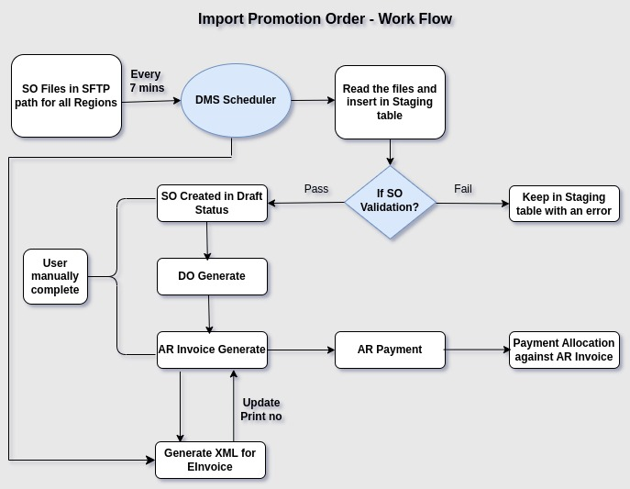
Business Rules:

- Import DMS Order runs at regular intervals of 7 minutes through “Import DMS Sales Order” scheduler.
- SFTP import file path configured under UM_FTP table as /DMSIntegration/ROW/FROM_DMS/initialize/Region (Ex: R1 , R2).
- Files name starts with SYN_SALE_ORDER will be read from above mentioned file path.
- File should be in CSV format.
- Import data will be stored in the I_Order staging table.
- File will be moved to completed folder (DMSIntegration/ROW/FROM_DMS/Region (Ex: R1 , R2)/Completed) if successfully imported otherwise goes to Failed folder (DMSIntegration/ROW/FROM_DMS/Region (Ex: R1 , R2)/failure ) in DMS.
- The following fields are mandatory while importing promotion order: Price List, Business partner, Payment Method, Product, Warehouse, etc.,
- Document type should be promotion order.
- SO reference should be unique.
- Once the validation done, then details updated in C_Order,C_OrderLine and C_OrderTax, I_SOCampaign and UM_SOCampaign tables. Finally, Promotion order will be created with Draft status. If any error found during validation the record will remain in Import promotion Order screen (I_Order Table) with appropriate error message.
- Promotion order will be completed in SO screen as single record or Batch complete promotion order form for bulk record

